Space News Update – June 2015
By Pat Williams
IN THIS EDITION:
- Philae and Rosetta.
- Pluto’s wobbly moons.
- Mars Odyssey 60,000 orbits and no pit stops.
- Tracking space weather.
- Hot lava flows discovered on Venus.
- Research in microgravity.
- Links to other space and astronomy news published in June 2015.
Disclaimer - I claim no authorship for the printed material; except where noted.
THIS EDITION AND ALL FUTURE EDITIONS WILL BE IN WORD FORMAT AS WELL AS PDF TO ENABLE READERS TO CUT AND PASTE ITEMS OF PERSONAL INTEREST.
PHILAE AND ROSETTA

Despite a new trajectory for Rosetta and a reduction of the distance between the orbiter and Comet 67P/Churyumov-Gerasimenko from 200 to 180 kilometres, contact with the Philae lander remains irregular and short.

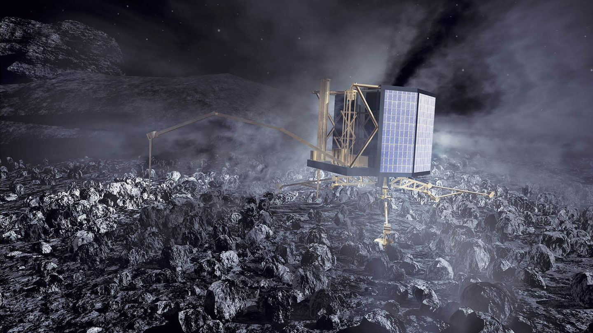Philae landing on the comet

After the initial contact on 13 June 2015, Philae has reported to the German Aerospace Center (Deutsches Zentrum für Luft- und Raumfahrt; DLR) Lander Control Center (LCC) in Cologne a total of six times. However, for the last three possibilities calculated for establishing a connection with Philae, no data could be received. "Right now, we are playing with the geometry between the Rosetta orbiter and the Philae lander," says DLR's Philae Project Manager, Stephan Ulamec. "The most recent contact – on 24 June 2015 – lasted 20 minutes; then, the line went dead again." Now, the DLR and ESA mission teams are analyzing which measures will make better contact with Philae possible.
Communication needs sunlight
Comet 67P/Churyumov-Gerasimenko has a rotation period of 12.4 hours, so a contact should be possible approximately twice per Earth day during an overflight by the Rosetta orbiter. But several conditions must be met before Philae can communicate with Rosetta and its control room in Darmstadt, and then with the LCC. Firstly, Philae must be in operation, and this can only happen when there is sufficient solar illumination for its solar panels to generate the necessary power. In addition, the antennas on the lander and the orbiter must be aligned. The performance of Philae’s antennas is partially affected by objects in the nearby and fairly harsh environment. Also, the Rosetta orbiter needs to align its antenna as closely as possible towards the comet. Contact with Philae still irregular and unstable (26 June 2015)
ROSETTA’S continued close study of Comet 67P/Churyumov–Gerasimenko has revealed an unexpected process at work, causing the rapid breakup of water and carbon dioxide molecules spewing from the comet’s surface.

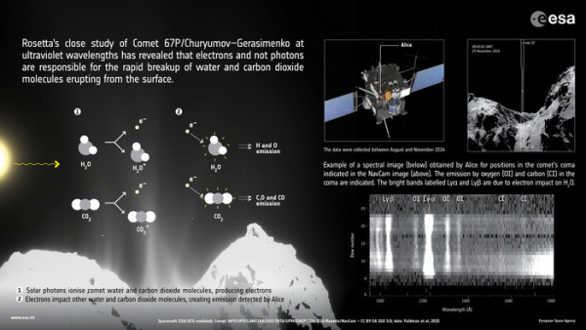
Rosetta uncovers processes at work in comet’s coma
(courtesy: spacecraft - ESA/ATG medialab;
comet, left - ESA/Rosetta/MPS for OSIRIS Team MPS/UPD/LAM/IAA/SSO/INTA/UPM/DASP/IDA;
comet, top right - ESA/Rosetta/NavCam – CC BY-SA IGO 3.0; data: Feldman et al)

The team focused on the nature of ‘plumes’ of water and carbon dioxide gas erupting from the comet’s surface, triggered by the warmth of the Sun. To do so, they looked at the emission from hydrogen and oxygen atoms resulting from broken water molecules, and similarly carbon atoms from carbon dioxide molecules, close to the comet nucleus. They discovered that the molecules seem to be broken up in a two-step process. First, an ultraviolet photon from the Sun hits a water molecule in the comet’s coma and ionises it, knocking out an energetic electron. This electron then hits another water molecule in the coma, breaking it apart into two hydrogen atoms and one oxygen, and energising them in the process. These atoms then emit ultraviolet light that is detected at characteristic wavelengths by Alice. Similarly, it is the impact of an electron with a carbon dioxide molecule that results in its break-up into atoms and the observed carbon emissions. Ultraviolet study reveals surprises in comet coma (2 June 2015)
PLUTO’S MOONS
Comprehensive analysis of data from NASA’s Hubble Space Telescope shows that two of Pluto’s moons, Nix and Hydra, wobble unpredictably.
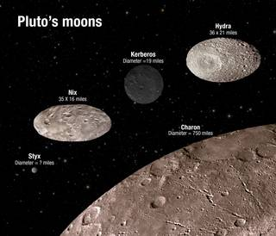 This illustration shows the scale and comparative brightness of Pluto’s small satellites. The surface craters are for illustration only and do not represent real imaging data. Credits: NASA/ESA/A. Feild (STScI)
If you lived on one of Pluto’s moons, you might have a hard time determining when, or from which direction, the sun will rise each day. Comprehensive analysis of data from NASA’s Hubble Space Telescope shows that two of Pluto’s moons, Nix and Hydra, wobble unpredictably.
The moons wobble because they’re embedded in a gravitational field that shifts constantly. This shift is created by the double planet system of Pluto and Charon as they whirl about each other. Pluto and Charon are called a double planet because they share a common center of gravity located in the space between the bodies. Their variable gravitational field sends the smaller moons tumbling erratically. The effect is strengthened by the football-like, rather than spherical, shape of the moons. Scientists believe it is likely Pluto’s other two moons, Kerberos and Styx, are in a similar situation. Hubble finds Pluto’s moons tumbling in absolute chaos (3 June 2015)

MARS ODYSSEY 60,000 ORBITS AND NO PIT STOPS

NASA's Mars Odyssey spacecraft will reach a major milestone June 23, when it completes its 60,000th orbit since arriving at the Red Planet in 2001. Named after the bestselling novel “2001: A Space Odyssey” by Arthur C. Clarke, Odyssey began orbiting Mars almost 14 years ago, on Oct. 23, 2001. On Dec. 15, 2010, it became the longest-operating spacecraft ever sent to Mars, and continues to hold that record today.
Odyssey, which discovered widespread water ice just beneath the surface of the Red Planet, is still going strong today, serving as a key communications relay for NASA's Mars rovers and making continued contributions to planetary science. Odyssey will continue to help lay a foundation for the first humans to Mars in the 2030s through NASA’s Journey to Mars initiative.
Odyssey’s orbital milestone translates into about 888 million miles (1.43 billion kilometers) traversed by the spacecraft. In addition to the 286 million miles (460 million kilometers) covered on its trip from Earth to Mars, the spacecraft is a high-mileage vehicle like no other, but remains in fine condition. The spacecraft is in good health, with all subsystems functional and with enough propellant for about 10 more years.
Odyssey's major discoveries began in the early months of its two-year primary mission, with gamma-ray and neutron measurements that indicated plentiful water ice just beneath the surface at high latitudes on Mars. The spacecraft's unexpectedly long service has enabled achievements such as completion of the highest-resolution global map of Mars and observation of seasonal and year-to-year changes, such as freezing and thawing of carbon dioxide. Through its many accomplishments, the spacecraft also has aided NASA’s preparations for human missions to Mars by monitoring radiation in the environment around the planet via the Mars Radiation Environment Experiment, developed at NASA’s Johnson Space Center in Houston. Veteran NASA spacecraft nears 60,000th orbit around Mars (19 June 2015)

TRACKING SPACE WEATHER

Satellite expected to begin operations this summer.

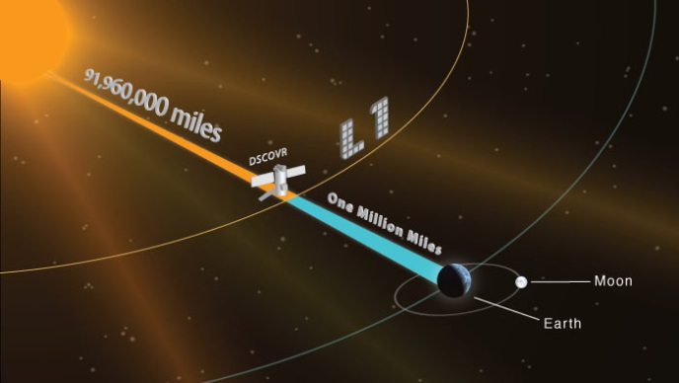
DSCOVR orbits the sun at a location called the Lagrange point 1, or L1. Credit: NOAA
More than 100 days after it launched, NOAA’s Deep Space Climate Observatory (DSCOVR) satellite has reached its orbit position about one million miles from Earth.

Once final instrument checks are completed, DSCOVR, which will provide improved measurements of solar wind conditions to enhance NOAA’s ability to warn of potentially harmful solar activity, will be the nation’s first operational space weather satellite in deep space. Its orbit between Earth and the sun is at a location called the Lagrange point 1, or L1, which gives DSCOVR a unique vantage point to see the Earth and sun.
Data from DSCOVR, coupled with a new forecast model set to come online in 2016, will enable NOAA’s space weather forecasters to predict geomagnetic storm magnitude on a regional basis. Geomagnetic storms occur when plasma and magnetic fields streaming from the sun impact Earth’s magnetic field. Large magnetic eruptions from the sun have the potential to bring major disruptions to power grids, aviation, telecommunications, and GPS systems.
“DSCOVR will trigger early warnings whenever it detects a surge of energy that could cause a geomagnetic storm that could bring possible damaging impacts for Earth,” said Stephen Volz, Ph.D., Assistant Administrator for NOAA’s Satellite and Information Service.
DSCOVR will eventually replace NASA’s Advanced Composition Explorer (ACE) research satellite as America’s primary warning system for solar magnetic storms headed towards Earth. ACE will continue to provide valuable research data to the science community.
In addition to space weather-monitoring instruments, DSCOVR is carrying two NASA Earth-observing instruments that will gather a range of measurements from ozone and aerosol amounts, to changes in Earth's radiation budget—the balance between incoming radiation (largely from the sun) and that which is reflected from Earth. This balance affects our climate. DSCOVR reaches L1 orbit (8 June 2015)

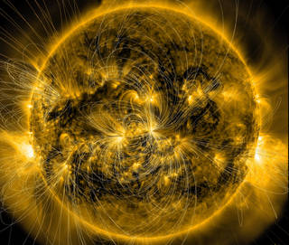
This image of the sun from January 7, 2014, combines a picture of the sun captured by NASA's Solar Dynamics Observatory, or SDO, with a model of the magnetic field lines using data that is also from SDO. A new model based on such data may one day help space weather forecasters better predict how eruptions from the sun will behave at Earth. Credits: NASA/SDO/LMSAL

"What we have now is effectively only a 30 to 60 minute heads up of a CME's configuration before it hits Earth's magnetosphere," said Neel Savani, a space scientist at NASA's Goddard Space Flight Center in Greenbelt, Maryland. "We don't have a real time method for measuring or modeling this magnetic field more than an hour before a space weather impact." Savani described a new model to measure the magnetic field configuration significantly further ahead of time in a paper appearing in Space Weather on June 9, 2015. The model is now undergoing testing, but if it's robust, then scientists might finally have a tool to predict a CME's magnetic configuration from afar. And that means forecasters could give utility grid and satellite operators a full 24-hour advance warning to protect their systems -- crucial time to protect their assets. New tool could track space weather 24 hours before reaching Earth (9 June 2015)

HOT LAVA FLOWS DISCOVERED ON VENUS

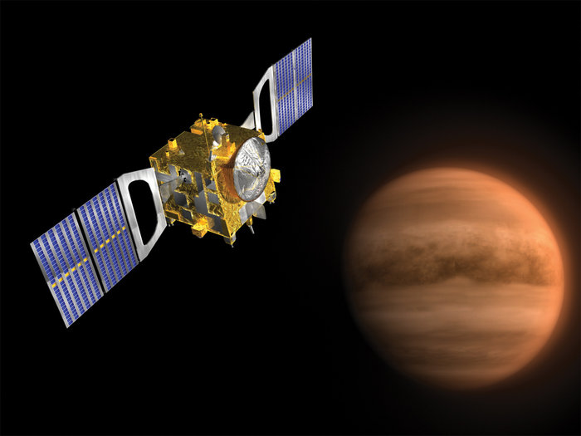
Venus Express Spacecraft. Copyright ESA/C.Carreau

ESA’s Venus Express has found the best evidence yet for active volcanism on Earth’s neighbour planet. Seeing the planet’s surface is extremely difficult due to its thick atmosphere, but radar observations by previous missions to Venus have revealed it as a world covered in volcanoes and ancient lava flows. Venus is almost exactly the same size as Earth and has a similar bulk composition, so is likely to have an internal heat source, perhaps due to radioactive heating. This heat has to escape somehow, and one possibility is that it does so in the form of volcanic eruptions.
Some models of planetary evolution suggest that Venus was resurfaced in a cataclysmic flood of lava around half a billion years ago. But whether Venus is active today has remained a hot topic in planetary science.
ESA’s Venus Express, which completed its eight-year study of the planet last year, conducted a range of observations at different wavelengths to address this important question. In a study published in 2010, scientists reported that the infrared radiation coming from three volcanic regions was different to that from the surrounding terrain. They interpreted this as coming from relatively fresh lava flows that had not yet experienced significant surface weathering. These flows were found to be less than 2.5 million years old, but the study could not establish whether there is still active volcanism on the planet. An additional piece of evidence was reported in 2012, showing a sharp rise in the sulphur dioxide content of the upper atmosphere in 2006–2007, followed by a gradual fall over the following five years. Although changes in wind patterns could have caused this, the more intriguing possibility is that episodes of volcanic activity were injecting vast amounts of sulphur dioxide into the upper atmosphere.
Now, using a near-infrared channel of the spacecraft’s Venus Monitoring Camera (VMC) to map thermal emission from the surface through a transparent spectral window in the planet’s atmosphere, an international team of planetary scientists has spotted localised changes in surface brightness between images taken only a few days apart.
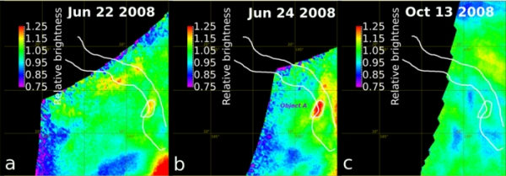
The Ganiki Chasma rift zone in Atla Regio on Venus was imaged repeatedly to look for changes. The maps presented here show changes in relative brightness compared to the average background (red-orange indicates an increase, blue-purple a decrease) for a number of images acquired on each date. While some changes are due to variations in cloud brightness, one fixed surface hot spot is inferred, labelled ‘Object A’, which shows an increase in brightness between 22 and 24 June 2008 followed by a decrease. (courtesy: E. Shalygin et al)
“We have now seen several events where a spot on the surface suddenly gets much hotter, and then cools down again,” says Eugene Shalygin from the Max Planck Institute for Solar System Research (MPS) in Germany, and lead author of the paper reporting the results in Geophysical Research Letters this month. “These four ‘hotspots’ are located in what are known from radar imagery to be tectonic rift zones, but this is the first time we have detected that they are hot and changing in temperature from day to day. It is the most tantalising evidence yet for active volcanism.” The hotspots are found along the Ganiki Chasma rift zone close to the volcanoes Ozza Mons and Maat Mons. Rift zones are results of fracturing of the surface, which is often associated with upwelling of magma below the crust. This process can bring hot material to the surface, where it may be released through fractures as a lava flow. “These observations are close to the limits of the spacecraft’s capabilities and it was extremely difficult to make these detections with Venus’ thick clouds impairing the view,” says co-author Wojciech Markiewicz. “But the VMC was designed to make these systematic observations of the surface and luckily we clearly see these regions that change in temperature over time, and that are notably higher than the average surface temperature.”
Because VMC’s view is blurred by the clouds, the areas of increased emission appear spread out over large areas more than 100 km across, but the hot regions on the surface below are probably much smaller. Indeed, for the hotspot known as ‘Object A’, the team calculate that the feature may only be around 1 square kilometre in size, with a temperature of 830°C, much higher than the global average of 480°C. The Ganiki Chasma rift zone was already considered to be one of the most recently geologically active regions on the planet, and as the new analysis suggests, it is still active today.
“It looks like we can finally include Venus in the small club of volcanically active Solar System bodies,” says Håkan Svedhem, ESA’s Venus Express project scientist. “Our study shows that Venus, our nearest neighbour, is still active and changing in the present day – it is an important step in our quest to understand the different evolutionary histories of Earth and Venus.” Hot lava flows discovered on Venus (18 June 2015)

ISS PLASMA RESEARCH

The International Space Station (ISS) offers a unique opportunity to conduct research in microgravity. Its newest research system – the PK-4 plasma crystal laboratory – has now begun scientific operations in the Columbus module.

Plasma is an electrically neutral gas made up of charged particles. If particles that are electrically charged are present in the plasma, plasma crystals and complex plasmas can arise. Only in microgravity does it become visible how the charged particles behave and influence one another. This image shows complex plasma in an orderly and fluid state – as the plasma particles propagate freely in the test chamber. They arrange themselves in a three-dimensional lattice structure. (courtesy: DLR)
The PK-4 laboratory is now fully operational. Padalka the man on site, had the delicate task of activating the measurement acquisition at the right moment. A command from the scientists in the control centre might not arrive at the laboratory at the right time. Data transfer between the Space Station and Earth is delayed by at least five seconds. Therefore, he had to take on the role of experimenter. In doing so, he demonstrated skilful timing – effortlessly capturing the fast moving particles in the plasma. Luckily, he had already worked on the two previous plasma research laboratories on the ISS. The Russian’s experience paid off, to the complete satisfaction of the scientists.
The spectacular images of the plasma experiments attracted the attention of the other cosmonauts and astronauts present in the Columbus Laboratory. They gathered around the PK-4 video monitor and watched as a stationary particle cloud suddenly transformed into a shear flow. This occurred when Padalka (with help from the control centre) directed a powerful laser beam into the complex liquid plasma to conduct the measurements.
The plasma crystal laboratory enables observation of the movement of individual particles in microgravity. Physical processes occurring at the atomic or molecular level become visible and can be investigated in a targeted manner. The next PK-4 experiments are expected to determine, among other things, particle charges and ion drag forces. These figures are essential for understanding the experiments on the ISS.
With PK-4, the Complex Plasmas Research Group is operating a laboratory on the ISS for the third time. The use of a virtual ‘telescience’ unit however, is completely new this time. The system is identical to the apparatus on board the ISS and is connected to it virtually. They can observe what is happening in the ‘real’ laboratory with their own eyes – and modify the sequence if necessary. Taking into consideration the delay in data transfer, the scientists can adapt the experiments to an altered situation for the first time. The plasma crystal laboratory is now expected to be operated on the ISS for at least four years. Plasma research – new laboratory on the ISS in operation (19 June 2015)

LINKS TO OTHER SPACE AND ASTRONOMY NEWS PUBLISHED IN JUNE 2015
ASTROPHYSICS
Cosmic ray observatory to expand (15 June 2015) Physicists plan a $6.4 million expansion of the $25 million Telescope Array observatory in Utah so they can zero in on a “hotspot” that seems to be a source of the most powerful particles in the universe: ultrahigh-energy cosmic rays.
Lab mimicry opens a window to the deep interiors of stars and planets (15 June 2015)
The matter that makes up distant planets and even-more-distant stars exists under extreme pressure and temperature conditions.

Is salt the key to unlocking the interiors of Neptune and Uranus? (22 June 2015)
The interiors of several of our Solar System’s planets and moons are icy, and ice has been found on distant extrasolar planets, as well.

BLACK HOLES
ALMA weighs supermassive black hole at centre of distant spiral galaxy (18 June 2015) Supermassive black holes lurk at the centre of every large galaxy.

How the brightest lights in the universe ‘flicker’ (24 June 2015)
Active galactic nuclei are the brightest objects in the universe. They are not lit up permanently, but rather ‘flicker’ extremely slowly.

Monster black hole wakes up after 26 years (25 June 2015)
Over the past week, ESA's Integral satellite has been observing an exceptional outburst of high-energy light produced by a black hole that is devouring material from its stellar companion.

COMET
The search for Philae – like a needle in a haystack (11 June 2015)
On 15 November 2014 at 01:15 CET, Philae's battery was exhausted and, after nearly 60 hours of operation on Comet 67P/Churyumov-Gerasimenko, the lander went into hibernation – in an unexpected place.
Rosetta's lander Philae wakes up from hibernation (14 June 2015)
Rosetta's lander Philae has woken up after seven months in hibernation on the surface of Comet 67P/Churyumov-Gerasimenko.
Nocturnal contact with Philae (15 June 2015)
The Philae lander reported back on 14 June 2015. From 23:22 to 23:26 CEST, the lander sent some data packets that are now being evaluated at the German Aerospace Centre (Deutsches Zentrum für Luft- und Raumfahrt; DLR).
Philae wake-up triggers intense planning (15 June 2015)
The receipt of signals from Rosetta’s Philae lander on 13 June after 211 days of hibernation marked the start of intense activity.
Lander Control Centre in contact with Philae once again (19 June 2015)
The team at the German Aerospace Centre (Deutsches Zentrum für Luft- und Raumfahrt; DLR) received data from the Philae lander for the third time on 19 June 2015.
Rosetta tracks debris around comet (19 July 2015)
In two papers, accepted for publication in Astronomy & Astrophysics, scientists provide an update on their study of debris around the comet.

MIRO maps water in comet's coma (19 June 2015)
In a paper accepted for publication in the journal Astronomy & Astrophysics, the MIRO team present their first map of water vapour in the coma of Comet 67P/Churyumov-Gerasimenko.
Rosetta mission extended (23 June 2015)
The adventure continues: ESA today confirmed that its Rosetta mission will be extended until the end of September 2016, at which point the spacecraft will most likely be landed on the surface of Comet 67P/Churyumov-Gerasimenko.
Exposed water ice detected on comet's surface (24 June 2015)
Using the high-resolution science camera on board ESA’s Rosetta spacecraft, scientists have identified more than a hundred patches of water ice a few metres in size on the surface of Comet 67P/Churyumov-Gerasimenko.

DARK MATTER
Black holes may make ideal dark matter labs (23 June 2015)
A new NASA computer simulation shows that dark matter particles colliding in the extreme gravity of a black hole can produce strong, potentially observable gamma-ray light.

EARTH

Real-time, 3D movies of plasma tubes drifting overhead (1 June 2015) By creatively using a radio telescope to see in 3D, astronomers have detected the existence of tubular plasma structures in the inner layers of the magnetosphere surrounding the Earth.
Chasing polar winds with lasers (4 June 2015)
Preparing for the launch of ESA’s Aeolus wind satellite next year, scientists from Europe and the US recently teamed up in Iceland to measure the wind over the North Atlantic.
Sentinel-1 brings radar remote sensing to new level (8 June 2015)
With frequent observations from the year-old Sentinel-1A radar satellite scientists are improving the remote sensing technique to map ground deformation, opening new doors for earthquake and volcano monitoring.
Next generation climate instrument successfully calibrated in the UK (12 June 2015)
A next generation satellite based sensor that is designed to advance our understanding of climate change has left the UK today after successfully completing a series of very challenging tests, and is en-route to the south of France for installation on the Sentinel 3 spacecraft.
New calculations to improve carbon dioxide monitoring from space (15 June 2015)
How light of different colours is absorbed by carbon dioxide (CO2) can now be accurately predicted using new calculations developed by a UCL-led team of scientists.
European space agencies step up space surveillance and tracking (17 June 2015)
Five European countries have this week agreed to do more to monitor and track space objects and detect their uncontrolled re-entry into Earth’s atmosphere.
Magnetic complexity begins to untangle (22 June 2015)
After a year in orbit, the three Swarm satellites have provided a first glimpse inside Earth and started to shed new light on the dynamics of the upper atmosphere – all the way from the ionosphere about 100 km above, through to the outer reaches of our protective magnetic shield.

EXOPLANETS

Circular orbits identified for small exoplanets (1 June 2015)
Viewed from above, our solar system’s planetary orbits around the sun resemble rings around a bulls-eye.
Helium-shrouded planets may be common in our galaxy (11 June 2015)
Planets with helium skies may constitute an exotic planetary class in our Milky Way galaxy.
Measuring the mass of a Mars-size exoplanet (17 June 2015)
Determining the size of an Earth-size exoplanet by the amount of starlight it blocks hundreds of light-years away once was the realm of science fiction.

Astronomers create array of Earth-like planet models (17 June 2015)
To sort out the biological intricacies of Earth-like planets, astronomers have developed computer models that examine how ultraviolet radiation from other planets’ nearby suns may affect those worlds, according to new research published June 10 in Astrophysical Journal.
'Behemoth' bleeding atmosphere around a warm Neptune-sized exoplanet (24 June 2015) Astronomers using NASA's Hubble Space Telescope have discovered an immense cloud of hydrogen dubbed "The Behemoth" bleeding off a planet orbiting a nearby star.

Spiral arms cradle baby terrestrial planets (25 June 2015)
New work from Carnegie’s Alan Boss offers a potential solution to a longstanding problem in the prevailing theory of how rocky planets formed in our own Solar System, as well as in others.

Can planets be rejuvenated around dead stars? (25 June 2015)
After years of growing old, a massive planet could, in theory, brighten up with a radiant, youthful glow.

FUTURE MISSIONS

ESA heading towards removing space debris (2 June 2015) ESA’s goal of removing a derelict satellite from orbit is picking up pace, as a mission design is assembled to be put before European ministers next year for approval.
ESA and Chinese Academy of Sciences to study SMILE as joint mission (4 June 2015)
European and Chinese scientists have recommended the Solar wind Magnetosphere Ionosphere Link Explorer as their candidate for a collaborative science mission for launch in 2021.
Three candidates for ESA's next medium-class science mission (4 June 2015)
Exoplanets, plasma physics and the X-ray Universe are the topics chosen by ESA to be considered for the fourth medium-class mission in its Cosmic Vision science programme, for launch in 2025.
‘Sunscreen’ layer on distant planet (11 June 2015)
NASA’s Hubble Space Telescope has detected a stratosphere, one of the primary layers of Earth’s atmosphere, on a massive and blazing-hot exoplanet known as WASP-33b.
Telescope's focus on target of ESA's asteroid mission (30 June 2015)
Telescopes around the globe recently homed in on one point in the sky, observing the paired Didymos asteroids – the target for ESA’s proposed Asteroid Impact Mission.
Final payload integration begins for Arianespace’s upcoming Ariane 5 launch (30 June 2015) Arianespace’s next Ariane 5 flight has entered its final preparations with installation of Star One C4 on the launcher’s SYLDA dual-passenger dispenser system – positioning it for the upper slot of this July 8 mission’s payload arrangement.

GALAXIES
Charting the Milky Way from the inside out (3 June 2015)
Recently, researchers have turned to a new method for mapping our galaxy that takes advantage of data from NASA's Wide-field Infrared Survey Explorer, or WISE.
Sharpest view ever of star formation in the distant universe (8 June 2015)
ALMA’s Long Baseline Campaign has produced a spectacular image of a distant galaxy being gravitationally lensed.
Magnetic-field discovery gives clues to galaxy-formation processes (18 June 2015)
Astronomers making a detailed, multi-telescope study of a nearby galaxy have discovered a magnetic field coiled around the galaxy's main spiral arm.
Ultra-dark galaxies in the Coma Cluster (22 June 2015)
A team of researchers from Stony Brook University and the National Astronomical Observatory of Japan (NAOJ) have discovered 854 “ultra-dark galaxies” in the Coma Cluster by analysing data from the 8.2-meter Subaru Telescope.
Discovering a new stage in the galactic lifecycle (24 June 2015)
On its own, dust seems fairly unremarkable. However, by observing the clouds of gas and dust within a galaxy, astronomers can determine important information about the history of star formation and the evolution of galaxies.
Giant galaxy is still growing (25 June 2015)
New observations with ESO’s Very Large Telescope have revealed that the giant elliptical galaxy Messier 87 has swallowed an entire medium-sized galaxy over the last billion years.

GAMMA-RAY BURST
Latest milestone reached for global gamma-ray astronomy project (26 June 2015)
The latest design milestone has been reached this week for the Cherenkov Telescope Array (CTA) project, an international astronomy initiative with major UK involvement that aims to build the next generation ground-based very high energy gamma-ray observatory.

INTERNATIONAL SPACE STATION
Expedition 43 crew departs Space Station, lands safely in Kazakhstan (11 June 2015)
Three crew members of the International Space Station (ISS) returned to Earth Thursday after a 199-day mission that included several spacewalks, technology demonstrations, and hundreds of scientific experiments spanning multiple disciplines, including human and plant biology.
Seventh SpaceX resupply mission to space station (19 June 2015)
NASA commercial partner SpaceX currently is targeting Sunday, June 28, for the launch of its seventh cargo delivery to the International Space Station under the agency’s Commercial Resupply Services contract.
CRS-7 lost in Falcon launch failure (28 June 2015)
Following a nominal liftoff, Falcon 9 experienced a problem shortly before first stage shutdown, resulting in loss of mission.
Cheek-muscles-hold-up-better-than-leg-muscles-in-space (30 June 2015)
It is well known that muscles need resistance (gravity) to maintain optimal health, and when they do not have this resistance, they deteriorate.
http://www.fasebj.org/content/current (Item 9)

MARS

Impact glass on surface of Mars (8 June 2015)

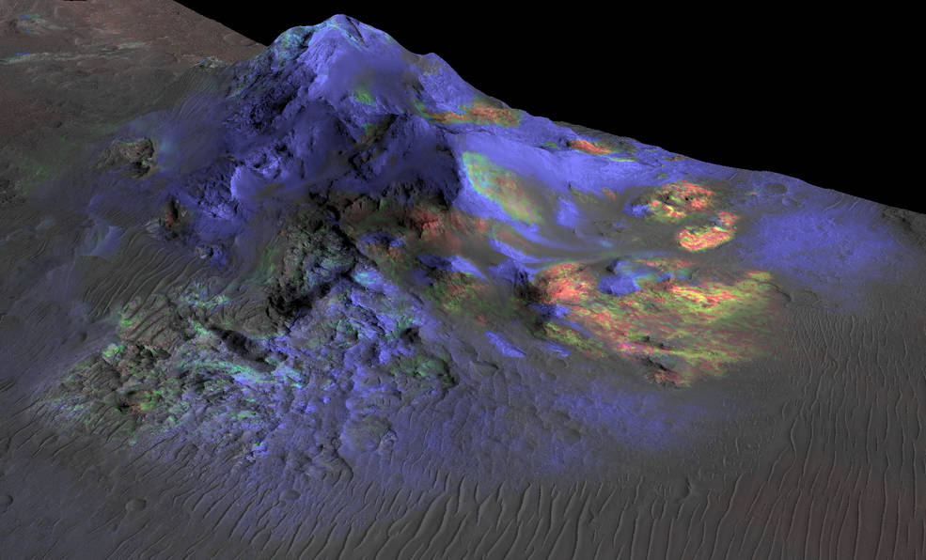
Researchers have found deposits of impact glass (in green) preserved in Martian craters, including Alga Crater, shown here. The detection is based on data from the instrument Compact Reconnaissance Imaging Spectrometer for Mars (CRISM) on NASA's Mars Reconnaissance Orbiter.
Credits: NASA/JPL-Caltech/JHUAPL/Univ. of Arizona

NASA's Mars Reconnaissance Orbiter (MRO) has detected deposits of glass within impact craters on Mars.
NASA prepares for first interplanetary CubeSats on agency’s next mission to Mars (12 June 2015) When NASA launches its next mission on the journey to Mars – a stationary lander in 2016 – the flight will include two CubeSats.
New study favours cold, icy early Mars (15 June 2015)
The high seas of Mars may never have existed, according to a new study that looks at two opposite climate scenarios of early Mars and suggests that a cold and icy planet billions of years ago better explains water drainage and erosion features seen on the planet today.

METEORITES
Methane found in Mars metorites (16 June 2015)
An international team of researchers has discovered traces of methane in Martian meteorites, a possible clue in the search for life on the Red Planet.

MOON
Crashing comets may explain mysterious lunar swirls (1 June 2015)
Brown University researchers have produced new evidence that lunar swirls — wispy bright regions scattered on the Moon’s surface — were created by several comet collisions over the last 100 million years.
Moon engulfed in permanent, lopsided dust cloud (17 June 2015)
The moon is engulfed in a permanent but lopsided dust cloud that increases in density when annual events like the Geminids spew shooting stars, according to a new study led by University of Colorado Boulder.
PLUTO
NAU scientists grow ice to support mission to Pluto (15 June 2015) As a worldwide audience awaits images from NASA’s New Horizons spacecraft flyby of Pluto on July 14, NAU scientists already are supporting astronomers’ understanding of the dwarf planet’s surface.
One month from Pluto (15 June 2015) Now within one month of the historic Pluto flyby, NASA’s New Horizons team has executed a small but important course correction for the spacecraft, completed updated analyses of possible hazards in the Pluto system, and is picking up the pace of science-data collection.
KinetX Aerospace navigation team critical to success of NASA's New Horizons mission to Pluto
(29 June 2015)
Carrying out a precise navigation operation involving the fastest spacecraft ever launched to the farthest destination ever explored, the KinetX Aerospace Space Navigation and Flight Dynamics team is homing in on its narrow target as NASA's New Horizons spacecraft makes its final approach to Pluto.

QUASARS

Hubble sees the 'teenage years' of quasars (18 June 2015)
Astronomers have used the Hubble Space Telescope's infrared vision to uncover the mysterious early formative years of quasars, the brightest objects in the universe.

SATURN AND MOONS

Cassini sends final close views of odd moon Hyperion (2 June 2015) NASA's Cassini spacecraft has returned images from its final close approach to Saturn's oddball moon Hyperion, upholding the moon's reputation as one of the most bizarre objects in the solar system.
Small thunderstorms may add up to massive cyclones on Saturn (15 June 2015)
For the last decade, astronomers have observed curious “hotspots” on Saturn’s poles.
Dissolving Titan (17 June 2015)
Saturn’s moon Titan is home to seas and lakes filled with liquid hydrocarbons, but what makes the depressions they lie in?
Titan's atmosphere even more Earth-like than previously thought (18 June 2015)
Scientists at UCL have observed how a widespread polar wind is driving gas from the atmosphere of Saturn's moon Titan.
Solving Saturn’s 2-billion-year age gap (26 June 2015)
Planets tend to cool as they get older, but Saturn is hotter than astrophysicists say it should be without some additional energy source.

STARS AND STAR CLUSTERS
A celestial butterfly emerges from its dusty cocoon (10 June 2015)
Some of the sharpest images ever made with ESO’s Very Large Telescope (VLT) have, for the first time, revealed what appears to be an ageing star giving birth to a butterfly-like planetary nebula.

Best observational evidence of first generation stars in the universe (17 June 2015)
Astronomers using ESO’s Very Large Telescope have discovered by far the brightest galaxy yet found in the early Universe and found strong evidence that examples of the first generation of stars lurk within it.

Intense radio emission from a tiny binary star calls for a review of stellar models (22 June 2015)
A study led by researchers in the Group of Radio Astronomy of the University of Valencia has determined the mass of a tiny binary star thanks to its intense radio emissions –rare in such small stars– which compels scientists to review stellar evolution models.
Chandra captures X-ray echoes pinpointing distant neutron star (23 June 2015)
Astronomers using NASA’s Chandra X-ray Observatory have discovered the largest and brightest set of rings from X-ray light echoes ever observed.
Precise ages of largest number of stars hosting planets ever measured (29 June 2015)
A new study of 33 Kepler stars with solar-like oscillations to be published in Monthly Notices of the Royal Astronomical Society.

SUPERNOVA
Exiled stars explode far from home (4 June 2015)
Sharp images obtained by the Hubble Space Telescope confirm that three supernovae discovered several years ago exploded in the dark emptiness of intergalactic space, having been flung from their home galaxies millions or billions of years earlier.

Seeing a supernova in a new light (29 June 2015)
Type Ia supernovae are the “standard candles” astrophysicists use to chart distance in the Universe.

TECHNOLOGY AND TECHNOLOGY TRANSFER

Microgravity experiments may help lighten the load of joint diseases (1 June 2015) Going into space might wreak havoc on our bodies, but a new set of microgravity experiments may help shed light on new approaches for treating cartilage diseases on Earth.
Historic handshake between space and Earth (3 June 2015)
ESA performed the first-ever demonstration of space-to-ground remote control with live video and force feedback today when NASA astronaut Terry Virts orbiting Earth on the International Space Station shook hands with ESA telerobotics specialist André Schiele in the Netherlands.
Construction to begin on largest telescope (3 June 2015)
The Giant Magellan Telescope Organization announced Wednesday that its 11 international partners have committed more than $500 million to begin construction of the first of a new generation of extremely large telescopes.
upGREAT – a new far-infrared spectrometer for SOFIA (2 June 2015)
The upgraded far-infrared spectrometer upGREAT has successfully completed its first deployment on board the Stratospheric Observatory for Infrared Astronomy (SOFIA), a joint project between the US Space Agency NASA and the German Aerospace Centre (Deutsches Zentrum für Luft- und Raumfahrt; DLR).
NASA selects eight projects for 2016 X-Hab Academic Innovation Challenge (8 June 2015)
NASA is working with eight U.S. universities on new technology projects for deep space exploration, including the agency’s journey to Mars, as part of the 2016 X-Hab Academic Innovation Challenge.

LightSail test mission landmark (8 June 2015)
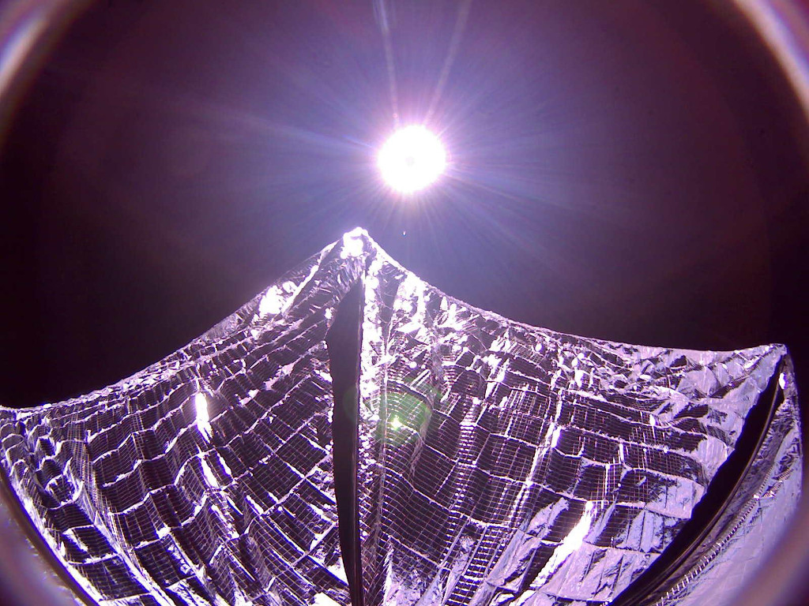

LightSail A
Image Credit: The Planetary Society
Hitching a ride to low Earth orbit, LightSail A accomplished a challenging test mission, unfurling its 32 square meter Mylar solar sail on June 7. This dramatic image from one of the bread loaf sized spacecraft's fisheye cameras captures the deployed sail glinting in sunlight. Sail out and visible to earthbound observers before its final orbit, LightSail A re-entered the atmosphere last weekend. Its successful demonstration paves the way for the LightSail B spacecraft, scheduled for launch in April 2016. Once considered the stuff of science fiction, sailing through space was suggested 400 years ago by astronomer Johannes Kepler who observed comet tails blown by the solar wind. But modern solar sail designs, like the one tested by LightSail A rely on the small but continuous pressure from sunlight itself for thrust. After 19 days on orbit, data indicate that The Planetary Society’s LightSail spacecraft deployed its Mylar solar sail in space.
Communicating with hypersonic vehicles in flight (16 June 2015) As a spacecraft hurtles into Earth's atmosphere it is encircled by hot ionized air that cuts off communications with the ground.
Detecting exoplanets close to their host stars (22 June 2015) Astronomers have successfully commissioned a new type of optic that can reveal the image of an exoplanet next to its parent star.
LISA Pathfinder – the first step towards observing Einstein’s gravitational waves from space
(29 June 2015) Complicated inner workings for a complicated proof: with the LISA Technology Package (LTP), Airbus Defence and Space has now delivered the heart of the LISA Pathfinder scientific space probe.
NASA collaborates with DRS Technologies to create mid-infrared detector (30 June 2015) NASA scientist Xiaoli Sun and his industry partner have created the world’s first photon-counting detector sensitive to the mid-infrared wavelength bands — a spectral sweet spot for a number of remote-sensing applications, including the detection of greenhouse gases on Earth, Mars and other planetary bodies, as well as ice and frost on comets, asteroids and the moon.
UNIVERSE
New model of cosmic stickiness favours “Big Rip” demise of universe (30 June 2015) The universe can be a very sticky place, but just how sticky is a matter of debate.

Pat Williams. June 2015

